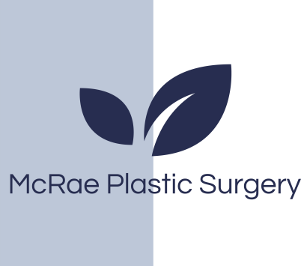
Post Care Instructions

All patients before surgery we recommend the following to reduce the risk of infection:
- Place Bactroban (Mupirocin) ointment in your nose at night 3 nights before surgery. Bactroban (Mupirocin) is a prescribed medication. You will receive this with your post op prescriptions one week before surgery.
- Use an antibiotic wash (Betadine or Chlorhexidine or any antibacterial soap) for your hair and body the night before and morning of surgery.
(This can be found over-the counter)

What To Expect During The 48 Hours Following Surgery
- Swelling and bruising around the eyes. This will increase during the 2-3 days following surgery.
- Some nasal bleeding – this will decrease and eventually stop. The gauze on your upper lip can be changed as needed.
- Packing may be placed in the nose during the surgery if there is a large amount of internal work done. Packing will cause a stuffy feeling in the nose. Packing will be removed by the doctor or nurse in the post operative visit after surgery.
- Take Tylenol regularly for pain control (1 gm every 6 hours if you have normal liver function). For nausea take Gravol or Ondansetron.
- Heavy bleeding/hemorrhaging is rare but can occur. If it does, hold your head back and call Dr. McRae or proceed to the emergency room.

What To Do 1-5 Days Following Surgery
- Do not blow your nose.
- To clean your nose, gently swab the base of the nose with a wet q-tip.
- Gently wash your face with a washcloth and warm water.
- You may shower after surgery but keep your face away from the shower spray to keep the cast as dry as possible.
- While in bed, keep head elevated with 2 pillows.
- Do not bend over or lift heavy objects for 1-3 weeks following surgery. (if bending - bend at knees)
- Do not smoke for 2 weeks prior to surgery and following surgery.
- Do not consume alcohol for 3 days before and following surgery.
- Avoid all vigorous activity following surgery. Walking is recommended. All physical activity can be resumed 4 weeks following surgery except contact sports which can be resumed 6 weeks following surgery.
McRae plastic surgery
St Michael’s Hospital 30 Bond Street Donnelly 4-076
Toronto ON M5B1W8
Phone 416-360-4000 x5830

Millcroft Professional Center Unit 2
4300 Upper Middle Road
Burlington On
(416)638-3499

Fax: 416-637-7608
E-mail: mcraeplasticsurgery@gmail.com

5-14 Days Following Surgery
- To clean nose, gentle saline nasal sprays may be used. You may apply Vaseline to the nares. Do not pock and prod in the nose
- Once the splint is removed do not rest glasses on the bridge of nose for 4 weeks following surgery. Aviator type frames that rest on the side of the nose can be worn.
- At time of splint removal the nose will be very swollen. 75% of the swelling will resolve within 4 weeks of surgery. The top of the nose takes 3 months, The swelling of the nasal tip can take up to a year to fully resolve. While the swelling goes down it commonly does so in an asymmetric manner for a period of time. Healing and swelling is not always predictable.
- To help reduce swelling in the early stages of recovery we recommend you use oral arnica. One brand we recommend is Boiron and can be purchased at your local drug store. Avoid salty and spicy foods after surgery that may increase swelling.
- Pets: it is important that you maintain your bedroom ‘clean and fresh’ from your pet(s) during your recovery period. Use bed linens that haven’t been exposed to your dog or cat.
- Call the office for a post-op appointment if one has not already been arranged for you.

McRaePlasticSurgery.com

McRae plastic surgery
St Michael’s Hospital 30 Bond Street Donnelly 4-076
Toronto ON M5B1W8
Phone 416-360-4000 x5830

Millcroft Professional Center Unit 2
4300 Upper Middle Road
Burlington On
(416)638-3499

Fax: 416-637-7608
E-mail: mcraeplasticsurgery@gmail.com

