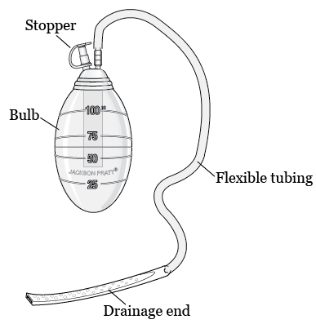
What is a Jackson-Pratt drain and how does it work?
- A Jackson-Pratt (JP) drain is used to remove fluids that build up in an area of your body after surgery. The JP drain is a bulb-shaped device connected to a tube. One end of the tube is placed inside you during surgery. The other end comes out through a small cut in your skin. The bulb is connected to this end. You may have a stitch to hold the tube in place.
- The JP drain removes fluids by creating suction in the tube. The bulb is squeezed flat and connected to the tube that sticks out of your body. The bulb expands as it fills with fluid.

How do I empty the Jackson-Pratt drain?
Empty the bulb when it is half full or every 8 to 12 hours.
- Wash your hands with soap and water.
- Remove the plug from the bulb.
- Pour the fluid into a measuring cup.
- Clean the plug with an alcohol swab or a cotton ball dipped in rubbing alcohol.
- Squeeze the bulb flat and put the plug back in. The bulb should stay flat until it starts to fill with fluid again.
- Measure the amount of fluid you pour out. Write down how much fluid you empty from the JP drain and the date and time you collected it.
- Flush the fluid down the toilet. Wash your hands.

What should I do if the tubing becomes clogged?
Use the following steps to clear your Jackson-Pratt tubing:
- Hold the tubing between your thumb and first finger at the place closest to your skin. This hand will prevent the tube from being pulled out of your skin.
- Use your other thumb and first finger to slide the clog down the tubing toward the bulb. You may have to repeat the sliding until the tubing is unclogged.

When will my Jackson-Pratt drain be removed?
The amount of fluid that you drain will decrease as your wound heals. The JP drain usually is removed when less than 30 milliliters (2 tablespoons) is collected in 24 hours for two consecutive days in a row. Outpatient Nursing care will remove the drains for you in the clinic.

What are the risks of having a Jackson-Pratt drain?
The JP drain site may be painful. You may have trouble lying on the side with your JP drain. Your JP drain site may leak. The JP drain may be pulled out by accident. The tubing may get blocked, crack, or break. The tubing may damage your tissue. You may have a scar. The JP drain site may get infected. This infection could spread inside your body.

When should I seek immediate care?
- Your JP drain breaks or comes out.
- You have cloudy yellow or brown drainage from your JP drain site, or the drainage smells bad.

When should I contact my healthcare provider?
- You suddenly stop draining fluid or think your JP drain is blocked.
- You have a fever higher than 101.5°F (38.6°C).
- You have increased pain, redness, or swelling around the drain site.
- You have questions about your JP drain care.

  McRae plastic surgery  St Michael’s Hospital 30 Bond Street Donnelly 4-076  Toronto ON M5B1W8  Phone 416-360-4000 x5830  Millcroft Professional Center Unit 2  4300 Upper Middle Road  Burlington On  416-638-3499  Fax: 416-637-7608  E-mail: mcraeplasticsurgery@gmail.com  Phone: 905.522.1155  DR. MARK MCRAE EXT. 32145  DR. MATT MCRAE EXT. 36092  Fax: 905.521.6156  E-mail: E-mail address  Phone: 905.522.1155  DR. MARK MCRAE EXT. 32145  DR. MATT MCRAE EXT. 36092  Fax: 905.521.6156  E-mail: E-mail address | McRaePlasticSurgery.com
  Date/Time | Left Side | Amount | Right Side | Amount

