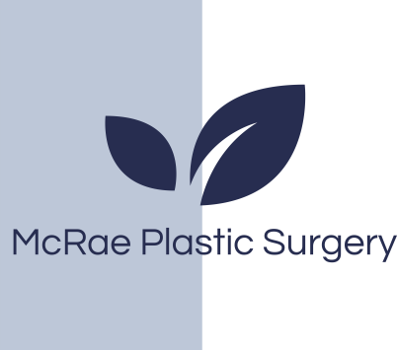
Post Care Instructions

All patients before surgery we recommend the following to reduce the risk of infection:
- Place Bactroban (Mupirocin) ointment in your nose at night 3 nights before surgery. Bactroban (Mupirocin) is a prescribed medication. You will receive this with your post op prescriptions one week before surgery.
- Use an antibiotic wash (Betadine or Chlorhexidine or other) for your hair and body the night before and morning of surgery.
(This can be found over-the counter)

Following Surgery
- While in bed sleep on your back.
- Stand up with good poster and shoulders back to allow your skin to best redrape on your chest.
- Limit the use of your arms for 2 weeks following surgery. No lifting of heavy objects. Do not drive during the week following surgery if your discomfort limits the movement of your arms.
- Your chest will be sore. Numbness, bruising and swelling of the chest area is normal and to be expected. The amount of bruising and swelling varies from patient to patient. It is not unusual to have asymmetry in the chest due to swelling. You may feel a pulling sensation in your chest as you heal.
- Avoid getting the chest wet until your first post-operative visit appointment. Following this appointment, you may shower/bath as desired.
- You will be given a prescription for pain medication. Only take it as needed. Tylenol should be taken around the clock 500mg every 4 hours, or 1 gm every 6 hours (if normal liver function) for the first several days. For nausea take Gravol or Ondansetron.
- Instructions for drain care will be given. Drains can be removed when less than 30 ml per 24 hour period for 2 consecutive days. Your nurse will remove the drains.
- Compression garment or chest binder should be worn for approximately 6 weeks.
- Massage is important to manage scar tissue development after surgery (commonly confused for recurrence). This may begin by you after your first post operative visit . Massage can also help your skin contract with less creasing and irregularities (caused by scar tissue and healing). Surgery is predictable but healing and scar tissue formation is quite variable. Your chest contour will be much improved but not perfect!
- There are no food restrictions, although salty and spicy foods tend to enhance swelling and should be avoided.
- Do not bend over or lift heavy objects for 2-3 weeks following surgery (if bending – bend at knees)
- Do not smoke for 4 weeks prior to surgery and 4 weeks following surgery.
- To help reduce swelling in the early stages of recovery we recommend you use oral arnica. One brand we recommend is Boiron and can be purchased at your local drug store. Avoid salty and spicy foods after surgery that may increase swelling.
- Reduce alcohol consumption for 3 days before and following surgery.
- Avoid all exercise, sports and vigorous activity for 4-6 weeks following surgery. Walking is recommended.
- Pets: it is important that you maintain your bedroom ‘clean and fresh’ from your pet(s) during your recovery period. Use bed linens that haven’t been exposed to your dog or cat.
- Return to work after being seen at your first post-op office visit.

McRae plastic surgery
St Michael’s Hospital 30 Bond Street Donnelly 4-076
Toronto ON M5B1W8
Phone 416-360-4000 x5830

Millcroft Professional Center Unit 2
4300 Upper Middle Road
Burlington On
(416)638-3499

Fax: 416-637-7608
E-mail: mcraeplasticsurgery@gmail.com

McRae plastic surgery
St Michael’s Hospital 30 Bond Street Donnelly 4-076
Toronto ON M5B1W8
Phone 416-360-4000 x5830

Millcroft Professional Center Unit 2
4300 Upper Middle Road
Burlington On
(416)638-3499

Fax: 416-637-7608
E-mail: mcraeplasticsurgery@gmail.com

