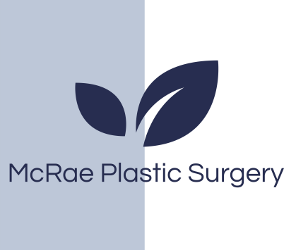
McRae plastic surgery
St Michael’s Hospital 30 Bond Street Donnelly 4-076
Toronto ON M5B1W8
Phone 416-360-4000 x5830

Millcroft Professional Center Unit 2
4300 Upper Middle Road
Burlington On
(416)638-3499

Fax: 416-637-7608
E-mail: mcraeplasticsurgery@gmail.com

Post Care Instructions

All patients before surgery we recommend the following to reduce the risk of infection:
- Place Bactroban (Mupirocin) ointment in your nose at night 3 nights before surgery. Bactroban (Mupirocin) is a prescribed medication. You will receive this with your post op prescriptions 1-2 weeks before surgery.
- Use an antibiotic wash (Betadine or Chlorhexidine or other) for your hair and body the night before and morning of surgery.
(This can be found over-the counter)

Following Surgery
- Sleep on your back for 2 weeks. Keep head elevated on 2 pillows while sleeping. Swelling bruising and numbness is normal and to be expected. Expect to feel tightness and a pulling sensation in your face and neck especially when turning your head. Your dressing will be removed by the nurse or by Dr. McRae.
- Wash your hair after your dressing is removed and daily thereafter for 2 weeks following surgery. Johnson’s baby shampoo or Neutrogena shampoo is suggested. Use a cool setting on the hair dryer.
- Do not use rollers for 1 week following surgery.
- Do not color hair or use any harsh chemicals for 2 weeks following surgery. Please use liquid antibacterial soap. It can be used directly over the incisions and steri strips. Be gentle with the incisions.
- There are no food restrictions. However, soft foods will be easier to consume.
- Do not bend over or lift heavy objects for 2 weeks following surgery (bending – bend at knees).
- Do not smoke for 6 weeks prior to and following surgery.
- Avoid vigorous exercise for 4 weeks following surgery. Walking is recommended.
- Pain medication: take Tylenol regularly as instructed. You have a narcotic for breakthrough pain. If you get nauseated, please take Gravol or Ondansetron.
- To help reduce swelling in the early stages of recovery we recommend you use oral arnica. One brand we recommend is Boiron and can be purchased at your local drug store. Avoid salty and spicy foods after surgery that may increase swelling.
- Pets: it is important that you maintain your bedroom ‘clean and fresh’ from your pet(s) during your recovery period. Use bed linens that haven’t been exposed to your dog or cat.
- Call the office for a post-op appointment if one has not already been arranged for you.

McRaePlasticSurgery.com

