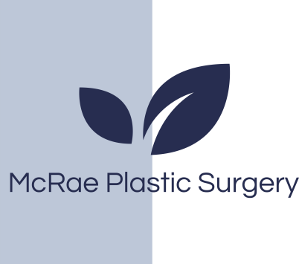
Post Care Instructions

All patients before surgery we recommend the following to reduce the risk of infection:
- Use an antibiotic wash (Betadine or Chlorhexidine or other antibacterial soap) for your hair and body the night before and morning of surgery.
(This can be found over-the counter)
Following Surgery
- While in bed sleep on your back.
- Limit the use of your arms for 2 weeks following surgery. No lifting of heavy objects. Do not drive during the week following surgery if your discomfort limits the movement of your arms.
- Your breasts will be heavy and sore. Numbness, bruising and swelling of the breast area is normal and to be expected. The amount of bruising and swelling varies from patient to patient. It is not unusual to have asymmetry in the size of your breasts due to swelling. You may feel a pulling sensation in your breasts as you heal.
- Avoid getting the breasts wet until your first post-operative visit appointment. Following this appointment, you may shower/bath as desired.
- You will be given a prescription for pain medication. Only take it as needed. Tylenol 1000mg can be taken every 6 hours (if you have normal liver function). This is most effective for pain. Take medications as directed.
- There are no food restrictions, although salty and spicy foods tend to enhance swelling and should be avoided.
- Do not bend over or lift heavy objects for 2-3 weeks following surgery (if bending – bend at knees)
- Do not smoke for 6 weeks prior to surgery and 6 weeks following surgery. Do not consume alcohol for 3 days before and following surgery.
- To help reduce swelling in the early stages of recovery we recommend you use oral arnica. One brand we recommend is Boiron and can be purchased at your local drug store. Avoid salty and spicy foods after surgery that may increase swelling.
- Avoid all exercise, sports and vigorous activity for 6 weeks following surgery. Walking is recommended.
- Pets: it is important that you maintain your bedroom ‘clean and fresh’ from your pet(s) during your recovery period. Use bed linens that haven’t been exposed to your dog or cat.

McRae plastic surgery
St Michael’s Hospital 30 Bond Street Donnelly 4-076
Toronto ON M5B1W8
Phone 416-360-4000 x5830

Millcroft Professional Center Unit 2
4300 Upper Middle Road
Burlington On
(416)638-3499

Fax: 416-637-7608
E-mail: mcraeplasticsurgery@gmail.com

Dr. Mark
McRae
MD, MHS, FRCSC
50 Charlton Ave E
Hamilton, ON
L8N 4A6

Phone: 905.522.1155
Admin ext. 32145
E-mail: oharakm@mcmaster.ca

